Welcome
It’s that time of year again, time for our Annual General Meeting! It’s worth having a quick scan of the report from the website on gmh.humanist.org.uk/archives/record-2016-17
to see what Greater Manchester Humanists (GMH) have been doing over the last year and the extent of our involvement in society generally. I would also draw your attention to our new newsletter feature on GMH members. I thought it would be nice to provide a summary profile of a GMH member each month. Derek McComiskey provides our first profile which I think you will agree provides an interesting read!

LOL!

A Bird Named Moses

A burglar breaks into a house. He starts shining his light around looking for valuables. Some nice things catch his eye, and as he reaches for them, he hears, “Jesus is watching you.” Startled, the burglar looks for the speaker. Seeing no one, he keeps putting things in his bag. Again, he hears, “Jesus is watching you.” This time, he sees a parrot.
“Who are you?” the burglar asks.
“Moses,” the bird replied.
“Who the heck would name a bird Moses?” asked the man.
“I dunno,” Moses answered, “I guess the same kind of people that would name a rottweiler Jesus.”
Readers Digest Jokes

Central Manchester Meeting – 12 April 2017

Open Discussion on GMH Creative Campaigning
Following on from suggestions from several of our members, we are now going to have a meeting where we can discuss Creative Campaigning. If you have thoughts and ideas, suggestions, please bring them along with you! Kevin will be looking at the possibility of making short videos to get GMH’s message across.
If you are new to GMH and/or have a real interest in a particular area, this is a real opportunity to come along and share your ideas, and also to get to know GMH members in a more relaxed scenario.
We meet at 7pm for a 7.30pm start at Friends Meeting House, 6 Mount Street, Manchester, M2 5NS. The Meetings formally end around 9pm but a number of us go on to The Waterhouse, 67-71 Street, Manchester for further discussion and liquid refreshment!
Contributions: We ask for the following contributions towards the cost of room hire: members £2.50; non-members £3.50 (students £1). However, there is no charge for those attending their first meeting. In addition, there is a charge of £1.50 for tea or coffee and a biscuit.

Upcoming Meetings

Humanist Discussion Group
Do you enjoy exploring contemporary social, political and philosophical themes? If so why not join GMH at their monthly discussion forum! The next meeting of the group will be held on Tuesday, 18 April and will discuss Epicurus. Notes for the meeting are posted on http://gmh.humanist.org.uk/record-2016-17/. We meet at The Waterhouse, 67-71 Princess Street, Manchester, M2 4EG at 8.15pm in one of the quieter spaces in the pub. The event is free but attendees are expected to buy a drink.

Central Manchester – Annual General Meeting 2017
The Annual General Meeting will take place on Wednesday, 10 May at 7.30pm at Friends Meeting House, 6 Mount Street, Manchester, M2 5NS. The Annual Report 2016-7 has been circulated to members and is available from the GMH website
gmh.humanist.org.uk/archives/record-2016-17
Members are urged to read the report before the meeting.

Bolton
The next meeting will take place at 7pm on Thursday, 13 April. The group will discuss Liberalism and the following questions: How far should we be expected to tolerate something unchallenged? When is something no longer free speech but hate speech? What isn’t acceptable and why?

The meeting will take place in the Mercury Hotel bar, 540 Manchester Road, Westhoughton. There is no charge to attend the meeting and all are welcome! Enquiries about the meeting or other group activities should be sent to BoltonHumanists@outlook.com

Oldham
The next meeting will take place at 2.30pm on Sunday, 16 April. The group have an informal discussion on the basic ideas of Humanism. The meeting will take place at the Squire Knott, 55 Yorkshire Street, Oldham, OL1 3SL. There is no charge to attend but attendees are expected to buy a drink. All are welcome!

Stockport Humanists
The next meeting will take place at 7.30pm on Wednesday, 19 April. John Webster from Oxford Humanists will deliver an audio-visual presentation to the group on the poet Shelley. John’s presentation gives an unrivalled insight into Shelley, and reveals the extent to which humanist ideals animated his work. With Shelley verses presented in a cycle of songs (‘an interesting and enjoyable way to encounter the lyrics’), a narration voiced by Benjamin Zephaniah, and images from Shelley locations in Italy, this is an excellent opportunity to discover the scope and ambition of the poet who looked forward to a democratic, pluralist and secular future.
The meeting will take place in the back room at the Boars Head, 2 Vernon Street, SK1 1TY (near the Market Place). There is a £2 charge (free for first timers).
The group’s next afternoon social will take place on 26 April at 2.30pm at the Rhode Island Coffee Bar, 2 Little Underbank, Stockport, SK1 1JT.

GMH Member Profiles
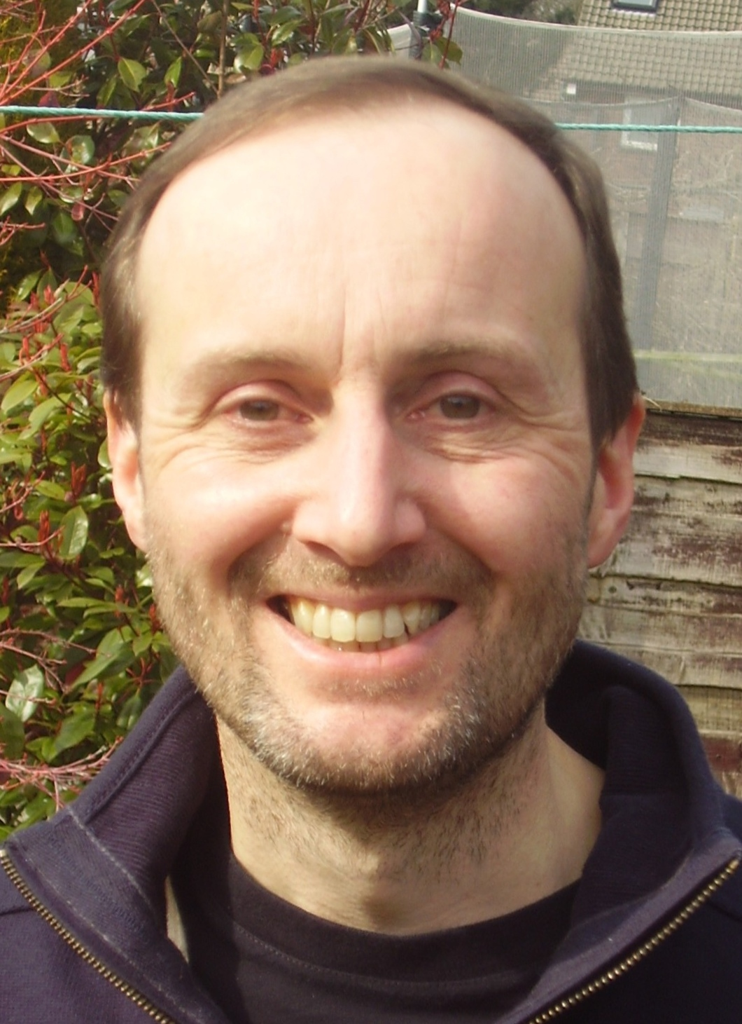
Name
Derek McComiskey
Do you consider yourself to be a Humanist?
Yes. An atheist and a Humanist.
Were you a member of another belief system before?
From my mid-teens to mid-twenties I was a fairly committed Christian, often in Anglican churches but leaning to the evangelical side.
What made you leave that belief system?
It was a long, slow process and I can't give a very coherent story about it. With hindsight (lots of "post-hoc rationalisation" here) I started to struggle when my Christian friends became interested in more miraculous things, particularly around the figure of John Wimber and the Vinyard movement. Then we moved away from a lively church when we moved for work, and we didn't really find anywhere to settle. So my faith sort of drifted away over a couple of years until I met a confident atheist at my workplace and later on I met Guy Otten who introduced me to Humanism.
How long have you been a member of Greater Manchester Humanists?
It must be nearly a decade since I found Humanism and GMH, but I don't recall very precisely.
What Greater Manchester Humanist activities do you enjoy doing and why?
I think we get some great speakers to the main meetings, and particularly enjoy socialising and continuing the conversation in The Waterhouse afterwards. I am more involved with the Stockport group these days where I am Treasurer. I enjoy helping out at an information stall we run at a couple of Fairs and Festivals over the summer. I very much appreciated the Introduction To Humanism course which I attended many years ago. Long may it continue (thank you Robin and Anna).
Has being connected to Humanism assisted you in your life, and if yes, in what way?
Finding Humanism felt like a validation of the ideas I had been working towards on my own for some time. I didn't know that I was part of this larger community, so finding it gave me access to helpful people and other resources.
What book are you reading at the moment?
I've just finished the Autobiography of Mark Twain (vol 1). There are sections of this he didn't want published until 100 years after his death so that he could be as brutally honest about people as he liked. This is much more considerate than today's memoir writers. I'm in the middle of Derren Brown's "Tricks of the Mind".

What are your hobbies?
Reading is my main hobby, but I don't get as much time as I would like. I am particularly fascinated by human evolution and by the origin of life (abiogenesis), so try to find out as much as I can about those topics.
If you could have one person (alive or dead) to dinner, who would you have and why?
This is a difficult one. I would love to have a long discussion with Nick Lane. He is one of the principal researchers in the origin of life. I believe he has a laboratory experiment going on to model a "white smoker" - a deep sea alkaline hydrothermal vent. There is good reason to think these may have been the site of the first biochemistry. So if he leaves his experiment running for the next 500,000 years ...
Can you provide an interesting fact about yourself?
There can't be many people who are in both the BHA and the BHI (The British Humanist Association and the British Horological Institute).

What GMH do in Schools
Rob Grinter is the BHA Regional Coordinator for educational inputs into schools in the North West and has provided the following outline of the work that GMH does in schools.
We currently have 15 volunteer speakers who visit schools. In 2016-17 36 such visits, to a total audience of 4,000 young people, were made to schools within a 30 mile radius of Manchester. In brief, when we talk to young people we tell them that they can be good without God, and that they can be as good as anyone who relies on God to help them be good. But we also assure those who have a faith that we recognise how important this is to them: what we hope is that they can see that their class mates who may or may not believe in a God, can be as good as them. We talk about how important it is to respect others and get on well with them. If we are speaking to older students we talk about social cohesion and the need for understanding of different beliefs and ways of life. But the more interesting bit, of course, is how we do it. First we establish good relations with the teachers. This is not difficult since they have invited us to come to their schools. As the coordinator of school visits, I make the first response and say that we respect the beliefs of their pupils or students, and are presenting an alternative, secular value system so that everyone’s beliefs are validated. I mention inclusiveness and social cohesion, and even that we hope that our input will help engage everyone in their teaching. I also try to involve teachers in the planning of our talk by asking them what input they would like. I encourage teachers to allow our speakers the opportunity to attend at classes as well as deliver at Assembly, which is the usual format. I also encourage teachers to get their students to prepare questions for speakers because we find that question/answer sessions are by far the best format. I have the initial consultation with the teacher and I then put the teacher in touch with one of our volunteer speakers who will organise the visit to the school.
Almost everything has gone really well. We get young people talking about issues and have had some really thoughtful discussions. Several schools invite us back, some on an annual basis.
However, it’s interesting that more and more teachers are in fact teaching Humanism, often as a Unit. This is usually within Religious Education, but we also find ourselves operating as a team of three or four in thematic days organised by PSHE staff. Examples of this have been world peace, British values, charitable work and ethical issues, and we make additions to our presentations to ensure that we provide a relevant Humanist perspective on the theme. Another point of interest is that although most of our work is within community schools without religious affiliation, several of these have high percentages of Muslim children. We are also receiving invitations from Church of England primary schools and Catholic High Schools.
If anyone is interested in finding out more about, or get involved with, the work that we do in schools please contact me Rob Grinter at robathome@ntlworld.com

GMH Choir – Call for new members
GMH members and non-members are invited to join the GMH choir! The choir is currently small in numbers and is a mixed ability group. The choir currently meets on most Sundays from 2pm to 4pm at Chorlton Unitarian Church, Wilbraham Road Chorlton M21 9LB. The building is behind a block of modern flats. If interested, contact Larry Bode at larry.a.bode@gmail.com

Exploring Humanism: An Introductory Course

Seven Tuesday evenings, 19 September to 31 October 2017, 7.00pm to 9.15pm

At Friends Meeting House, 6 Mount Street, Manchester M2 5NS
The course has run for the last 8 years, and this year will be its thirteenth presentation!
It’s for anyone who is interested in finding out what Humanism has to offer as a non-religious way of answering the ‘big questions’ of life, and developing values that help us live enjoyable and worthwhile lives. Humanism provides the ideal value system for a secular society.
The course is interactive and enjoyable, with video clips, an input on Humanist ceremonies and group discussions of interesting and challenging issues with like-minded people. The course fee is £20 with an ‘early bird’ reduction to £17 for applications received by September 4. For further details and application form please contact Robin Grinter on robathome@ntlworld.com

Joint Book Club (GMH and Sunday Assembly)
We are pleased to announce that GMH and Sunday Assembly have set up a book club that will meet on a monthly basis. Following a successful first meeting on 30 March the next club meeting will take place on Thursday, 27 April at 7.30pm at The Wonder Inn, 29 Shudehill, M4 2AF. A fiction and non-fiction book will be discussed in alternate months. The details of April’s book will appear shortly on www.meetup.com/greater-manchester-humanists

Amble and Rambles
GMH will be ambling and rambling again this summer! We will hold a number of walks on Sundays which will start at 11am and involve a two hour, generally flat, walk. We will refresh ourselves either during or after the walk at a café or a pub. The first walk will take place on 30 April around Sale and Chorlton Water Parks and along the River Mersey and will involve a stop at Jackson’s Boat Inn. The distance can be extended if desired. Good walking shoes and wet weather gear are advisable. The meeting point is the Mersey Valley Visitor Centre, Rifle Road, Sale, M33 2LX which is just off Junction 6 of the M60. Free parking is available at the Centre. The Sale Water Park tram stop is a 5 minute walk from the Visitor Centre. Please contact Rob Grinter at robathome@ntlworld.com with any queries.

Other Events

Conscientious Objectors Day
To commemorate Conscientious Objectors Day on Monday, 15 May the Friends of Manchester Peace garden will hold a ceremony at 5pm in Lincoln Square. This will consist of singing from a local choir, reading out the names of objectors from Manchester and the North West, poetry readings, and the laying of flowers.

From the BHA

Liberal Democrats vote to end religious selection amongst state schools
In March 2017 the Liberal Democrats passed new party policy to support an end to religious selection in state-funded schools in England. The policy also calls for all state schools to teach impartial education about religious and non-religious worldviews that is inspected by Ofsted, for much stricter limits on religious discrimination in ‘faith’ school employment, and for the current legal requirement for schools to hold daily acts of collective worship to be repealed, scrapping those rules and introducing 100% selection.

MPs vote in favour of decriminalising abortion in England and Wales
In March 2017 members of the House of Commons voted by 172 to 142 in favour of a Ten Minute Rule bill brought by Diana Johnson MP, to decriminalise abortion in England and Wales. Currently women across the UK can be sent to jail for having an abortion without the permission of two doctors, even if she does so within the first 24 weeks of pregnancy. The BHA is also supporting campaigns to decriminalise abortion in Northern Ireland, where it is currently illegal in almost all circumstances

European Court of Justice ruling on employees wearing religious clothing
The European Court of Justice (ECJ) issued a ruling in March 2017 that general rules prohibiting employees from ‘the visible wearing of any political, philosophical or religious sign’, including headscarves, on the basis of neutrality, need not constitute direct discrimination under European employment law. It may constitute indirect discrimination, if it puts ‘persons adhering to a particular religion or belief being put at a particular disadvantage’. The British Humanist Association (BHA) has emphasised the need for freedom of expression albeit whilst balancing it with the rights of others.

New Report: ‘faith’ schools ‘more ethnically segregated’, ‘more likely to cater to more advantaged students’.
‘Faith’ schools in England are ‘more ethnically segregated than schools of no faith’ and ‘more likely to cater to more advantaged students’, according to a report issued in March 2017, entitled Understanding School Segregation in England: 2011 to 2016.

Membership
We now have:
- 89 paid up members
- 791 on our email list
- 315 Meet-up Group members
- 567 Facebook Group members

Annual subscriptions are £15 for waged and £10 unwaged. If you’d like to become a member of GMH you can download our brochure, which includes a membership application form, from http://gmh.humanist.org.uk/home/contact-us/.
We offer 18 months membership for your initial subscription if you take out a standing order. To take up this offer, please complete the membership application and the standing order form which can be downloaded from the same link, and return them both to us with your cheque for your first subscription (plus any additional donation). The date of the first payment under your standing order should be 18 months after the date on which you complete the membership application form.

Keep In Touch
For more about what’s going on at GMH check out some of the links below.
 http://www.meetup.com/Greater-Manchester-Humanists
https://www.facebook.com/GreaterManchesterHumanists
https://www.facebook.com/groups/5231173231/
gmhumanists.blogspot.co.uk
@gmhumanists
 http://gmh.humanist.org.uk/

 Feedback
If you would like to comment on this newsletter or send in suggestions for future content (jokes, articles, links, book reviews or whatever) please email the editor at: newsletter_editor@gmh.humanist.org.uk

Cathryn McGarvey – Newsletter Editor

