Welcome
Welcome to November! This month’s newsletter provides and outline of the upcoming meetings for November and December, provides you with a profile of Graham Connell, one of the groups long standing members, continues with Stefan Coopers observations on Alcoholics Anonymous and also provides an important message from Guy Otten on Humanism and political approaches!
LOL!
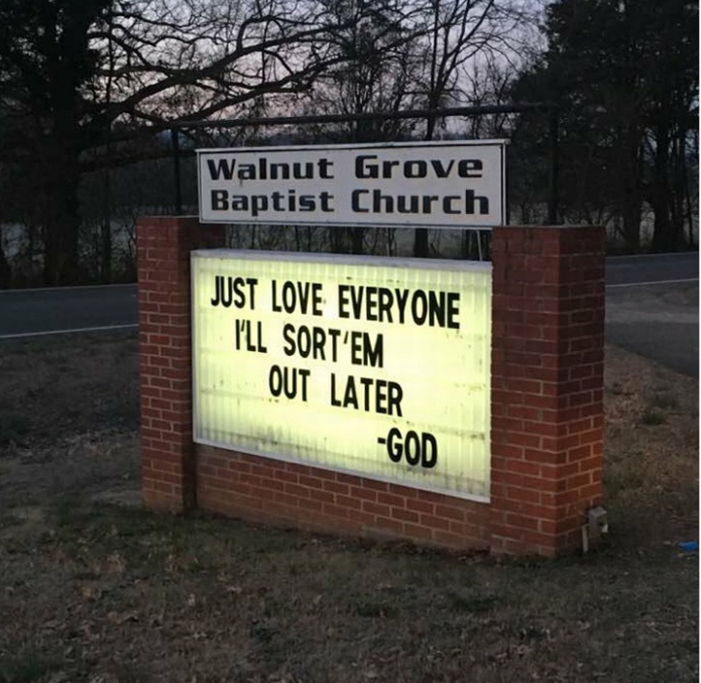

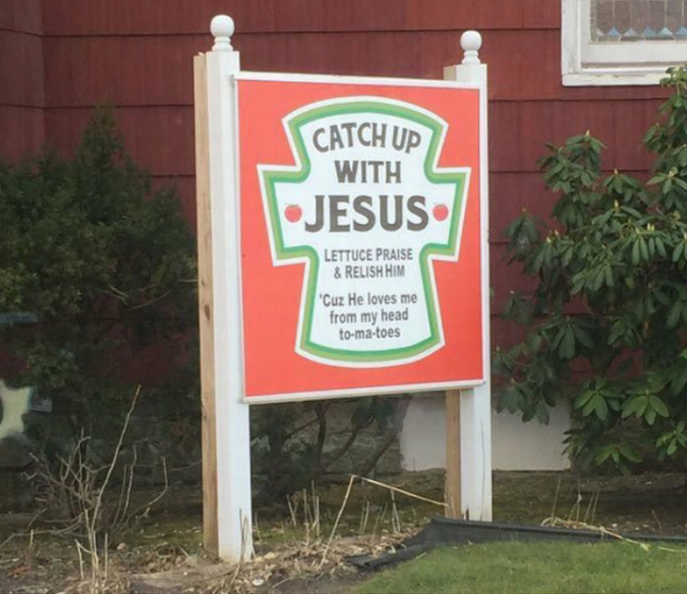

Upcoming Meetings

GMH and Sunday Assembly Book Club
The next book club meeting will take place on Thursday 7 December. The group will discuss 'Christ died at Eboli' by Carlo Levi. Do note that the venue has changed and the meeting now takes place at the Crowne Plaza Hotel, 70 Shudehill, Manchester M4 4AF at 7.30pm.
The details of the book are posted on
https://www.meetup.com/Greater-Manchester-Humanists/events/243186409/
The meeting is free but attendees are expected to buy a drink.

Central Manchester Events

December 2017

Social and Dinner
The December meeting is a social and dinner and it will be held at 7pm on Wednesday 13 December at Home Restaurant (1st floor), Tony Wilson Place, Manchester, M15 4FN. The menu is provided here https://homemcr.org/visit/food-and-drink/menus/christmas/. If you would like to join the group at the meal email your three course choices to david.milne@ntlworld.com

January 2018

Humanists UK Major Incident Support Project
On Wednesday 10 January Richard Spedding, Volunteer Project Manager at Humanists UK will talk to the group about Humanists UK’s new project around the organisations involvement in disaster and incident responses.
The meeting will take place at Friends Meeting House, 6 Mount Street, Manchester, M2 5NS. Meetings formally end around 9pm but a number of us go on to The Waterhouse, 67-71 Street, Manchester for further discussion and liquid refreshment!
Contributions: We ask for the following contributions towards the cost of room hire: members £2.50; non-members £3.50 (students £1). However, there is no charge for those attending their first meeting. In addition, there is a charge of £1.50 for tea or coffee and a biscuit.

Oldham
The next meeting will take place at 2.00pm on Saturday 18 November. The group will have an informal discussion on the basic ideas of Humanism. The meeting will take place at the Rhode Island Cafe
Spindles Shopping Centre, Oldham OL1 1HD. There is no charge to attend but attendees are expected to buy a drink. All are welcome!

Stockport Humanists
The next meeting will take place at 7.30pm on Wednesday 15 November. Jeremy Rodell, the Dialogue Officer of Humanists UK will discuss the topic "Britain's Changing Religion and Belief Landscape". We're currently living through what has been referred to as the biggest change in the religion and belief landscape in Britain since the Reformation, 500 years ago. But what's really going on? What are the facts? And how can humanists respond? The meetings will take place in the back room at the Boars Head, 2 Vernon Street, SK1 1TY (near the Market Place). There is a £2 charge (free for first timers).

The group’s next afternoon social will take place on Wednesday 22 November at 2.30pm at the Rhode Island Coffee Bar, 2 Little Underbank, Stockport, SK1 1JT.

Humanist Discussion Group
Do you enjoy exploring contemporary social, political and philosophical themes? If so, why not join GMH at their monthly discussion forum in Central Manchester! The next meeting of the group will be held on Tuesday 29 November and will discuss Douglas Murray’s new book “The Strange Death of Europe”. Notes for the meeting will be posted on http://gmh.humanist.org.uk/record-2017-18/ The meeting will take place at The Waterhouse, 67-71 Princess Street, Manchester, M2 4EG at 8.15pm in one of the quieter spaces in the pub. The event is free but attendees are expected to buy a drink.

Humanists UK School Speakers Training
Humanists UK are looking for volunteers to visit schools to deliver talks on Humanism. The organisation offers training on planning and delivering talks, assemblies, and workshops. Further information about training as a school volunteer can be found on the Humanists UK Groups Hub https://sites.google.com/a/humanism.org.uk/groups-hub/working-in-schools/bha-school-speaker-faqs?amp%3Bqid=
A training course will be take place on Saturday 18 November 2017 from 9am to 5pm at a venue yet to be agreed in the West Midlands, most likely Birmingham. Applications are invited to express an interest in attending on one of the specified courses or a future event by completing the following application form https://humanism.org.uk/education/schoolvolunteers/train-as-a-school-volunteer/?amp%3Bqid=
Further training courses will be organised in the coming months at locations according to expressions of interest. Any questions relating to the programme should be directed to Luke Donnellan at luke@humanism.org.uk

GMH Member Profiles
Name
Graham Connell
Do you consider yourself to be a Humanist?
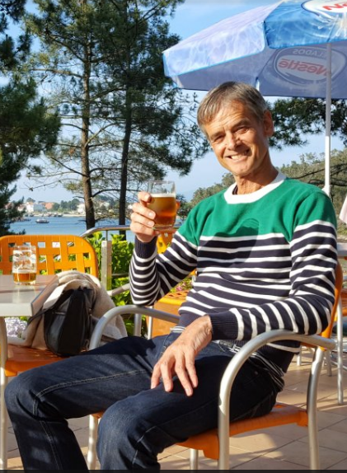
Yes
Were you a member of another belief system before?
I went to a CofE church every week from about the age of 8 to 13 because I was in the church choir. And I was a believer during that time.
What made you leave that belief system and associate yourself with Humanism?
I started to have doubts in my late teens and by the time I was in my twenties I was a convinced atheist. I didn't know about Humanism till I heard about the BHA's Humanist Bus Campaign and that motivated me to get involved in humanism.
How long have you been a member of Greater Manchester Humanists?
About 7 or 8 years I think.
What Greater Manchester Humanist activities do you enjoy doing and why?
Attending monthly meetings, especially the ones that are more interactive, and the pub afterwards. The Christmas meal is always a good night out. It's good to hear different points of view on what you would think was fairly common ground.
Has being connected to Humanism assisted you in your life, and if yes, in what way?
Not directly no, but it's made me see the word differently, and opened my eyes to areas of science and philosophy that I was not aware of. Likewise my knowledge of religions generally has improved enormously.
What book(s) are you reading at the moment and how are you finding it?
My bedtime reading is usually a crime novel, or other light reading. The one I'm reading at the moment is The Trapped Girl by Robert Dugoni, and it's a good read. I usually have a heavier one for when I'm on holiday. The one I'm going to read next is Intuition Pumps and Other Tools for Thinking, by Daniel C. Dennet.
What are your hobbies?
I really enjoy cycling, both doing and watching. I also like watching football and support Manchester City. And I enjoy playing guitar and singing. I used to be in a band but stopped that about 4 years ago. I still meet up with one of my old band mates though for a playing and singing session.
If you could have one person (alive or dead) to dinner, who would you have and why?
You know I find that a really difficult question to answer. My first thought was Christopher Hitchens because he speaks so eloquently about his atheism and his knowledge of religion. But I suspect finding a topic in which I could meaningfully contribute would be difficult. Then I thought about inviting someone like Tony Blair or Theresa May so that I could ask the why they believe in imaginary beings and allow themselves to be guided by them, and have pushed a faith schools agenda. But then I thought that could be a bit like an interrogation so not really very hospitable towards a dinner guest. So, I'm going to have to go for a musician and being a big Beatles fan, Paul McCartney. I'd love to hear him talk about his early life, the coming together of the Beatles, their days in Hamburg and the Cavern and what they did when they weren't playing.
Can you provide one interesting fact about yourself?
The theme music to Desert Island Discs on the radio makes me feel ill.

Humanism and Politics – A message from Guy Otten
From time to time remarks are made or assumptions are revealed in our meetings which imply that humanists are on the left or ‘progressive’ side of the political spectrum, and occasionally even voice is given to the idea that those on the right are in some sense beyond the pale.
So I think it right to remind ourselves that humanism is not partial politically; we are not a branch of, nor identified with, any political movement. We have much more that unites us which stands outside the left-right-liberal-green spectra of political debates. We are united for instance in our opposition to religious privilege, and in our commitment to living our lives without reference to gods, the search for a life stance based on rationalism and the need to build a humanist culture and community.
We are of course thoughtful people interested in ideas and social change – and we share this outlook with those who are engaged politically across the spectrum, so it isn’t surprising some of us feel strongly. But we risk becoming weaker as a Humanist movement if we give the impression that Humanism is somehow restricted in who can belong.
As a Humanist community we welcome folk of the full range of political persuasions, and in our discussions and interactions I ask that we honour such openness and welcome contributions from all.
The following are the links to the principal party’s humanist associations:
http://conservativehumanists.org.uk/
https://hsld.org.uk/en/
https://labourhumanists.org.uk/

Adventures in Anonymous
In a series running over a number of months, Stefan Cooper, GMH member, will outline his experiences and observations of anonymous organisations, Alcoholics Anonymous (AA) and Narcotics Anonymous (NA) as pseudo religious organisations with cultish tendencies. Up to now Stefan has described how he became immersed in the anonymous’ world, the strains of working for a rehab organisation and the fundamental flaws associated with the 12 steps programme. In the fifth instalment, Stefan continues to outline his criticism of the Anonymous model.
Disease Model
I had never considered the idea of my using being a disease before attending Anonymous. I’m certain some people are pre-disposed to addictive behaviour through genetics, terrible childhoods, and simple bad luck. However, I felt that once somebody got clean as an adult any subsequent relapse had to be a choice. I know that I had repeatedly chosen to take any substance I used long after I had realised it wasn’t enjoyable. There were different reasons, motivations, and sets of circumstances that caused me to do this but pinning any of it on a disease felt like a cop out.
I had changed my whole lifestyle to avoid any situation where there was alcohol, even checking food labels for alcoholic ingredients. No more Christmas pudding with Brandy in it. There were countless other adjustments to be made in a world that seemed to be swamped with alcohol. However hard this was, doing and continuing to do it was my choice. Everyone in recovery has to make their own small personal changes, and nobody else can enforce better choices on you long-term.
I would have been embarrassed to claim my using was a disease to somebody that suffered from a real medical condition, as there is no element of choice in them having it. The person with diabetes doesn’t choose to have it or not, they just simply have it. I imagine turning up at my mother’s house drunk saying that it was not entirely my fault, that I had a disease. I would guess that wouldn’t get me much sympathy, and I don’t think a cancer sufferer would give you much time for using-disease either.
I think addiction can feel like a disease, like there’s some unwelcome thing inside your brain compelling you to use. An addict has usually really tried to stop using countless times, but failed to last very long despite every good intention. Getting clean/relapsing for years might seem analogous with somebody fighting cancer for example – there’s ups and downs, relapse and remission, good days and bad etc. However, addiction feeling like a disease doesn’t make it one. I even heard people argue that the disease was “dis-ease” i.e. two different words not one. This meant that they were ill at ease with themselves, or uncomfortable in their own skin. I certainly felt like that at times, but self-consciousness is not a disease. This is a perfect example of Anonymous recoveryspeak taking a word from the real world, and bending it into meaning something else that’s quite different.
I found people sharing about disease relating to relapse as a bit dramatic and self-pitying. It sounded like some people were telling themselves something over and over until they believed it, which then made relapse more acceptable. Addicts are often looking for any reason to help justify their using behaviour, and it seemed like the disease idea positively encouraged relapse. I heard people say that relapse is part of recovery, whatever that might mean.
I realised that if I thought like this, then it would be too easy to relapse and blame it on the disease. When people died after relapsing, which sadly did happen from time to time, people spoke about it in the same way you might talk of a death in a random car accident. In that it was an unlucky event that didn’t have anything to do with the individual’s choice to use again. In this way, anonymous creates an atmosphere that is totally devoid of any personal responsibility. Portraying addiction as anything else than a choice is the single most dangerous thing that could be said to somebody with a problem.
Fear
Anonymous tells you unequivocally that it is the answer and the only answer. The Big Book of AA in particular says that repeatedly. People do leave and relapse then die. It’s scary when that happens. To be told that this could be you if you don’t comply creates real fear. I can see now that fear kept me clean for a while. I was so scared of relapse that I believed what I was told, and I don’t blame them as they simply don’t know of any other way. Anonymous was all they knew, and everyone that they knew was in anonymous and so on. It creates what I now know would be called an echo chamber or confirmation bias. Fear will work for a certain period of time, maybe even for years, but ultimately it creates either relapse or deeply unhappy people who resent having to go to meetings.
If you go to 3 meetings in a day every day, nobody will tell you it’s getting a bit much and it might be an idea to get a job or join a gym instead. Quite the reverse, members proudly announce how many meetings they have been to. I once met a man in his late 80s who had been sober longer than I had been alive at the time (40 years) and he still went to a meeting every single day, as he didn’t want to relapse. His dedication to daily anonymous meetings since 1972 seemed both admirable and quite sad at the same time, as he seemed scared to do something else.
It seems so obvious to see through the logic now, but obviously any group of people sat in a room who got clean by X method will swear by it. The people who got clean through Z method are not in that room, so you don’t hear from them. All the addicts of the world who just stopped by willpower alone, or through a prison sentence, or took up trampolining, or whatever else are not in the meeting. All the people who went to anonymous meeting, decided it wasn’t for them, then left but remained sober aren’t there either.
Sponsors
The idea of sponsors is another aspect of anonymous that I eventually came to see as doing more harm than good. It’s not hard to see why. The assumption is that clean time and doing the 12 steps equates with suitability to help the vulnerable newcomer. Clean time is held as the trump card that outdoes everything else. Long term clean time is all anybody wants on day one, and at the time being years clean seems like such a mountain to climb. Of course clean time is important, but it’s perfectly possible to be 20 years clean and be completely insane, hugely in debt, and be totally miserable. It doesn’t mean you are in a fit state to comment on how anybody else should be living their life.
Even assuming a sponsor lives according to the 12 steps, as you will see when I go through them, they don’t make much sense and are open to limitless interpretation. However, in step four the sponsor is supposed to hear literally all the things the sponsor has ever done wrong in their life. Imagine what that would sound like, coming from a lifelong drug addict.
There is no vetting, training, or standards whatsoever for who can sponsor newcomers. Everything in anonymous is subjective, suggested rather than specific, and no checks on competence. If somebody asks you to sponsor them, then you can say yes and that’s all there is to it. Imagine starting an organisation today that had thousands of damaged and vulnerable human beings turn up each week. Then pairing them up with somebody else who has no other qualification than simply saying they are clean, but you have no way of knowing for certain. Then just stop there, and hope for the best.
Obviously, in the vast majority of cases sponsorship doesn’t work out. It’s not uncommon for sponsors to relapse, causing yet more damage to an already damaged newcomer.

From Humanists UK

New book by Andrew Copson, Humanists UK Chief Executive
Andrew Copson has published a new booked entitled Secularism: politics, religion, and freedom. It is now available to buy online and from all good book shops.

Luxembourg ends faith-based education
Humanists UK congratulates its sister organisation in Luxembourg, the Alliance of Humanists, Atheists, and Agnostics, on a truly stunning advance for inclusive secular common sense: Luxembourg has replaced its extremely Catholic faith-based RE with a new subject called 'Life and Society.' The Education Ministry stated that the new classes were intended to transform schools into places of equality, where children learn to respect each other and other viewpoints and with an increased emphasis on coexistence among diverse groups. These steps come as Luxembourg moves away from being a country with an established religion to a secular state.

Restrictive abortion laws result in 25 million unsafe abortions a year worldwide
A recent World Health Organisation report, published in The Lancet, showed that between 2010 and 2014 25 million unsafe abortions were performed worldwide each year. The overwhelming majority of these abortions occurred in Africa, Asia, and Latin America. Humanists UK has said that the study, in highlighting the link between countries maintaining strict prohibitive laws and the number of unsafe abortions performed, shows the need for reform.
It was found that in countries where abortion is completely prohibited or only permitted when a woman’s life is a risk, that 75% of abortions are unsafe. Conversely, in permissive jurisdictions 90% of abortions are performed safely. The study found no link between the number of abortions performed and the level of restriction in law.

Second Humanist pastoral carer appointed to hospital
Paul Noble has been appointed as a paid humanist pastoral carer at the University Hospital Southampton NHS Foundation Trust. This is the second paid appointment in a hospital attained by a member of the Non-Religious Pastoral Support Network (NRPSN), Humanists UK’s network of accredited non-religious volunteers who provide pastoral support in hospitals, prisons and the armed forces.

Ireland announces it will hold referendums on abortion and blasphemy in the summer and winter of 2018
Ireland’s Taoiseach (Prime Minister), Leo Varadkar, has announced in Parliament that referendums repealing the country’s bans on abortion and blasphemy will take place in 2018.

Lancashire County Council votes to ban non-stunned meat from its schools
Lancashire County Council has voted to end the provision of non-stunned meat in its local maintained schools. Non-stunned slaughter involves the cutting of an animal’s throat whilst the animal is still fully conscious and alert. Current regulations specify that all animals must be stunned so that they are insensitive to pain at the time of slaughter but loopholes in this law allow Muslims and Jews to slaughter meat in accordance with halal and kosher traditions without stunning, for consumption only by members of their respective religions.

Membership
We now have:
- 91 paid up members
- 852 on our email list
- 356 Meet-up Group members
- 559 Facebook Group members
Annual subscriptions are £15 for waged and £10 unwaged. If you’d like to become a member of GMH you can download our brochure, which includes a membership application form, from http://gmh.humanist.org.uk/home/contact-us/.
We offer 18 months membership for your initial subscription if you take out a standing order. To take up this offer, please complete the membership application and the standing order form which can be downloaded from the same link, and return them both to us with your cheque for your first subscription (plus any additional donation). The date of the first payment under your standing order should be 18 months after the date on which you complete the membership application form.

Keep In Touch
For more about what’s going on at GMH check out some of the links below.
 http://www.meetup.com/Greater-Manchester-Humanists
https://www.facebook.com/GreaterManchesterHumanists
https://www.facebook.com/groups/5231173231/
gmhumanists.blogspot.co.uk
@gmhumanists http://gmh.humanist.org.uk/
 Feedback
If you would like to comment on this newsletter or send in suggestions for future content (jokes, articles, links, book reviews or whatever) please email the editor at: newsletter_editor@gmh.humanist.org.uk
Cathryn McGarvey – Newsletter Editor

